Functional Document for

Cake API

CAKE also has API's specific to your affiliates - called Affiliate API's. These can be found within our Affiliate API Library or the affiliate can access them directly from within the Affiliate Portal. Advertisers also have access to API's through the Advertiser Portal and even buyers have limited API's to pull reports and modify leads and each set of API's require an admin API key, affiliate API key, etc.

Where do I find my Admin API Key?

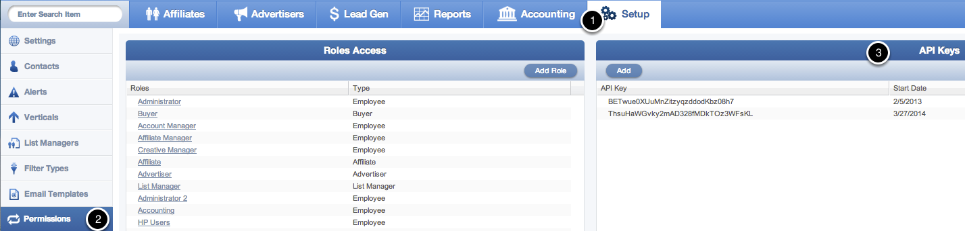

Your CAKE instance was populated with a default API Key which can be accessed from within the Admin interface.

To find it, click on Setup > Permissions > API Keys.

You can additionally add extra API keys here as well.

The following are the required credentials to extract data from cake API

http://<your_domain_here>/api/5/report.asmx?op=Affiliates

**Parameters**

|  |  |
| --- | --- |
| **api_key** *Required* Type: STRING Length (Max/Min): 50 | This api_key will provide you with the ability to export Campaigns for your instance. You can obtain this api_key from within CAKE >> Setup >> Permissions in the API Key list.  **Example Value:**  Fo35NRAqvFLXoZxqB4aViaiYM7iVMhh |
| **affiliate_id** *Required* Type: INTEGER Length (Max/Min): N/A | This is the identifier for a unique Affiliate.  **Example Values:** 1234 |
| **affiliate_name** *Optional* Type: STRING Length (Max/Min): 50 | Not required and can accept blank value. Used to filter records matching the value or will return all records if blank.  **Example Values:** John Smith |
| **account_manager_id** *Optional* Type: INTEGER Length (Max/Min): N/A | If passing anything <= 0 the result will include all advertisers.  **Example Values:** 1234 |
| **start_at_row** *Required* Type: INTEGER Length (Max/Min): N/A | Must pass at least 0 as value, which means start at the beginning of the data set.  **Example Values:** 3 |
| **row_limit** *Required* Type: INTEGER Length (Max/Min): N/A | Must pass at least 0 as value, which means no limit.  **Example Values:** 3 |
| **sort_field** *Required* Type: INTEGER Length (Max/Min): N/A | Accepts "affiliate_id", "affiliate_name", "date_created" or 0 to ignore this filter.  **Example Values:** 3 |
| **sort_descending** *Required* Type: BOOL Length (Max/Min): N/A | The following values can only be used for this parameter (TRUE or FALSE).  **Example Values:** TRUE |
| **tag_id** *Required* Type: INTEGER Length (Max/Min): N/A | Passing a zero (0) value will return all records. Passing an actual value will filter records matching the value. Obtained via GET AffiliateTags API  **Example Values:** 3 |

***\*\*Note all optional parameters still need to be passed through in the actual call. These parameters do not need a value (therefore you can use a null value).***

**Example Request**

http://demo.cakemarketing.com/api/4/report.asmx/Affiliates?api_key=dNJFmId9rI&affiliate_id=0&affiliate_name=&account_manager_id=0&tag_id=0&start_at_row=1&row_limit=1&sort_field=affiliate_id&sort descending=FALSE

**Sample XML Response:**

affiliate_export_response>

  <success>true</success>

  <row_count>1140</row_count>

  <affiliates>

    <affiliate>

      <affiliate_id>1</affiliate_id>

      <affiliate_name>Performance + Media Network</affiliate_name>

      <tier>

        <affiliate_tier_id>1</affiliate_tier_id>

        <affiliate_tier_name>Bronze</affiliate_tier_name>

      </tier>

      <account_managers>

        <contact>

          <contact_id>2660</contact_id>

          <contact_name>Jodi Warner</contact_name>

        </contact>

      </account_managers>

      <account_status>

        <account_status_id>1</account_status_id>

        <account_status_name>Active</account_status_name>

      </account_status>

      <address>

        <street_1>1234 W. Some Street</street_1>

        <street_2/>

        <city>Los Angeles</city>

        <state/>

        <zip_code>90120</zip_code>

        <country/>

      </address>